

**VIRTUAL REALITY**

**CSC5027Z**

**VRCamp UX Design**

**Zenan Shang (SHNZEN001)**

**Erin Heath (HTHERI001)**

**Mike Muponda (MPNMIK001)**



1. **Motivation**

Each member proposed a virtual environment (VE) that we can develop. With them being:

* Assembling the gun at a shooting range and then shooting at the target
* Creating a bond and training a dragon to become a dragon rider
* Build a camp in the wild, relax and cook some food.

Assembling the gun is feasible as there are a lot of assets in the Unity asset store that can do such. However, James said that there are previous groups that have created this environment, it is also boring in the sense that many games and previous projects are doing the same thing.

Becoming a dragon rider requires more equipment to make it realistic. For example, when riding the dragon and it flies up and down, the rider’s body will lean forward and backward because of that. We cannot recreate that sense of feeling because we don’t have any equipment that can generate that. Therefore, the flying process is susceptible to making the users feel motion sickness.

Building a camp was our final decision because it is unique since no past projects have implemented a VE like this. It is interactive as there are many processes to make fire by drilling work. It is a relaxing experience, therefore we assume it won’t create as much motion sickness compared to other projects. It would also be very educational for users to learn how to make fire without actually making physical fire.

1. **Storyline:**

The player, let's call her Jess, enters the scene and finds herself on the beach facing the ocean. Jess is a nature enthusiast and decided to set up a campfire for the night, but in a more primitive manner, reminiscent of ancient times when modern tools were not available.

Next to her, she will find all the materials needed for making the campfire. The materials include wood sticks, planks, foliage, and material to use as a fan. So what Jess must do to make the fire is that she must drill wood to make fire. To do that, Jess will first need to place the plank on the ground and take a stick to constantly rotate in her hands until she can see some smoke and fire sparks coming out of the plank. Then she must place the foliage onto the fire spark and flap the fan to make the fire. Once the fire is set, she will start adding wood to the fire to propagate it into a full campfire. Then she can sit on a chair to watch the sunset and beautiful northern light during the night. There are some further actions Jess can do other than watching the beautiful environment. Jess can roast marshmallows and eat them while enjoying the view or Jess can also take a wood stick and light it on fire to make a torch where she can explore around the area.

1. **Scene Design**

Camp Area

The VE is centred around the campground which is a mostly open area divided into sections including ocean, beach, campsite and trees. At the very centre of the campsite is the campfire site which is where the user will light a fire. The main elements of the campsite include a tent, camp chair, and campfire area. Jess will need to obtain various materials to start the fire, however, such as sticks, fan, birds’ nests and other foliage. To obtain these materials, Jess will need to search around the various areas of the scene. She can find items like planks, sticks, and leaves. Big leaves can be used as a fan. The scene is designed such that Jess goes from a phase of collecting materials, followed by a step of lighting the fire and then relaxation whilst eating marshmallows which is explored deeper in the interaction section.

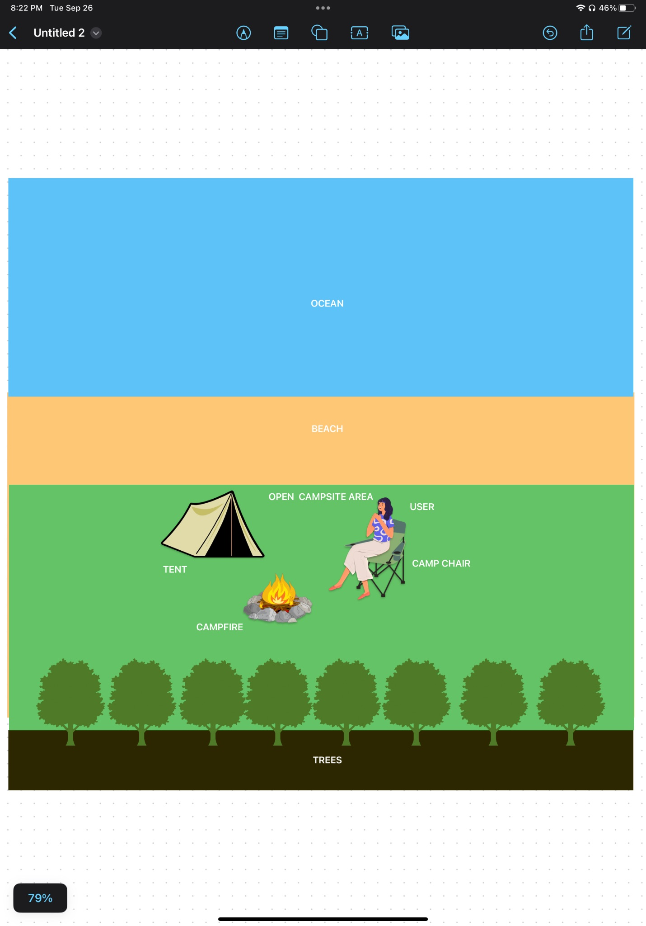

1. **Interactions**

The VE has several interactions that flow seamlessly from one to the next. These will take the user as Jess from the spawn point in the VE to the last section which terminates with her relaxing, eating some marshmallows while taking in the scenery. She spawns in with a survival guide as well. Figure 1 is a state diagram representing the flow of the VE. Below is a detailed breakdown of that process :

* 1. Gather required materials – 1 foliage, 10 sticks, 1 plank and 1 fan which will be located by exploring the VE. Jess will find the required materials randomly scattered around the VE. Relevant materials will glow
  2. Locate the campfire spot – this is the designated spot where Jess can begin lighting the fire.
  3. Hand drilling – this process has two stages. Using 1 stick and 1 plank, In the first stage Jess needs to drill the plank at a speed greater than x which upon reaching she’ll see smoke. For the second stage, Jess needs to drill for a time greater than n seconds which upon reaching she’ll see sparks and hear crackles. Variables x and n will need to be determined through user testing.
  4. Adding foliage – Jess will need to add at least 1 foliage for the fire to propagate although this number could be adjusted based on testing.
  5. Fan - Jess will need to fan the flame at a speed greater than x and time greater than n which will also be determined during testing. After achieving this condition the fire will have visible flames
  6. Sticks and marshmallows – Jess will add the remaining sticks to sustain the fire and the last stick will be used to hold marshmallows for roasting.
  7. Cooking marshmallows – Jess will cook marshmallows by satisfying two conditions. The first condition is she’ll need to hold marshmallows within some radius r. The second condition is she’ll need to do so whilst within radius r for some time t seconds upon which the marshmallows will change colour and thus cook thoroughly. Appropriate values for r and t will be determined from user testing as well.

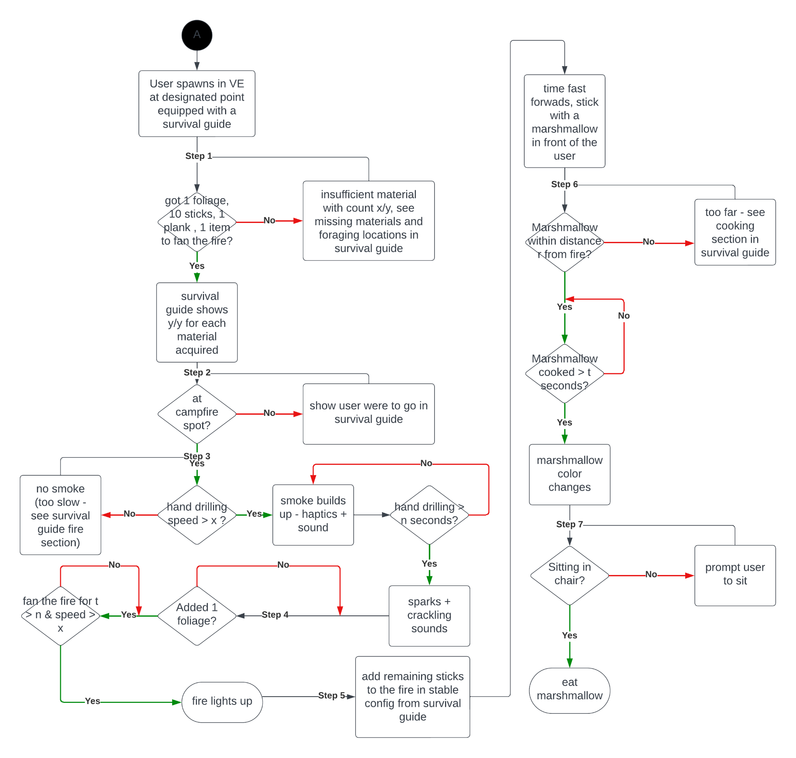

1. **Prototype:**

Our prototype can be divided into 3 parts according to the storyline. Firstly, the player needs to set up the fire using the wood, plank, foliage and fan. Secondly, the player can relax on the chair watching the sunset and beautiful northern sky. Lastly, the player can light a torch and explore the areas that Jess is in.

Part 1: Setting up the fire

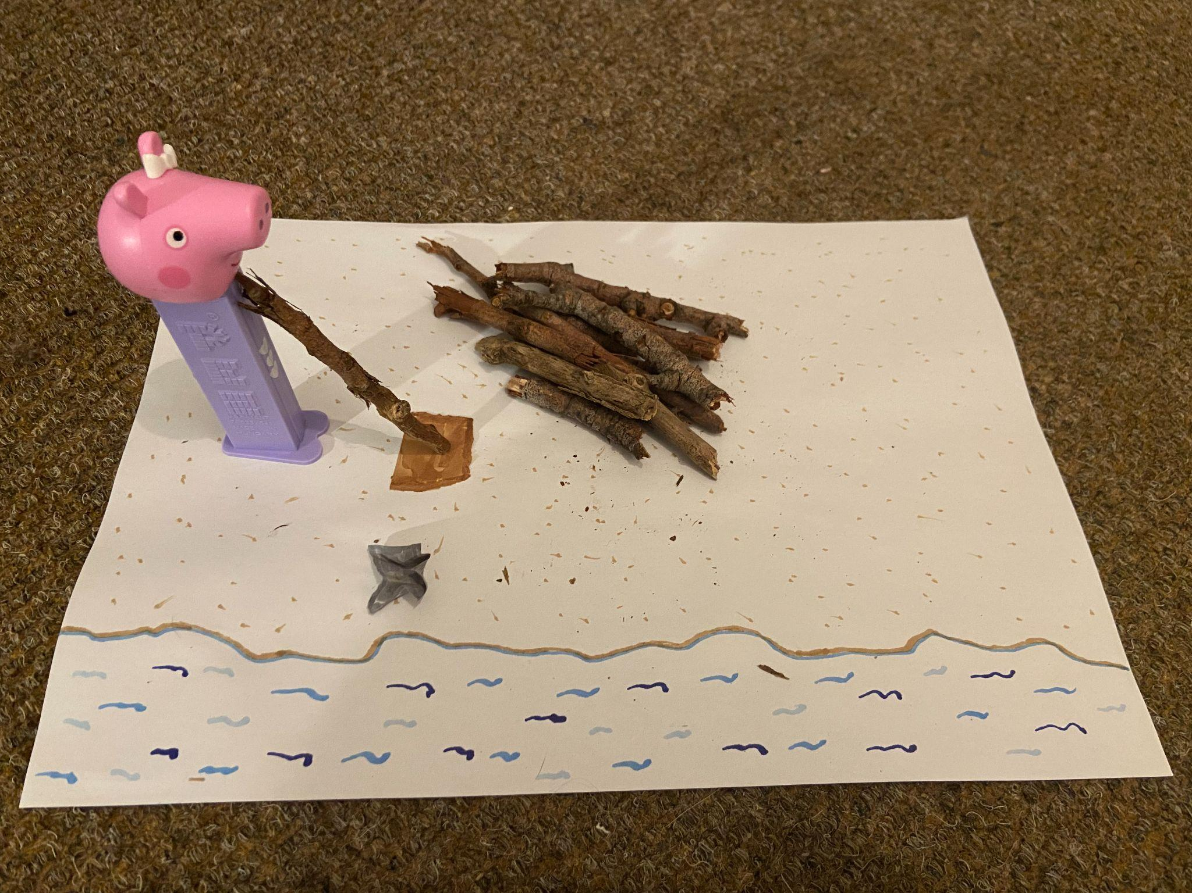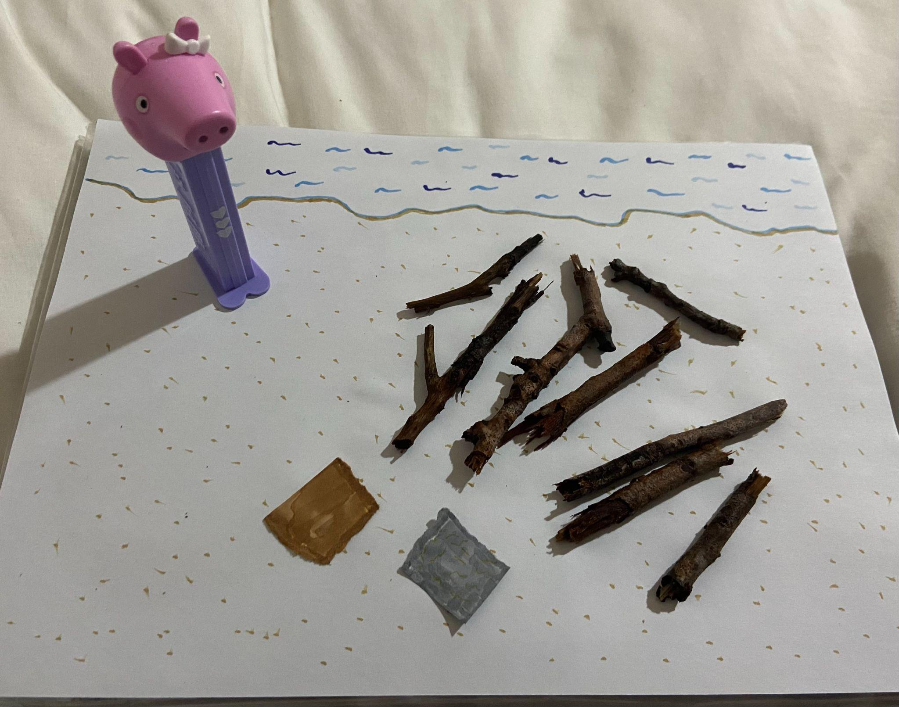

Jess initially immersed into the VRE Jess gathered sticks & drilling wood

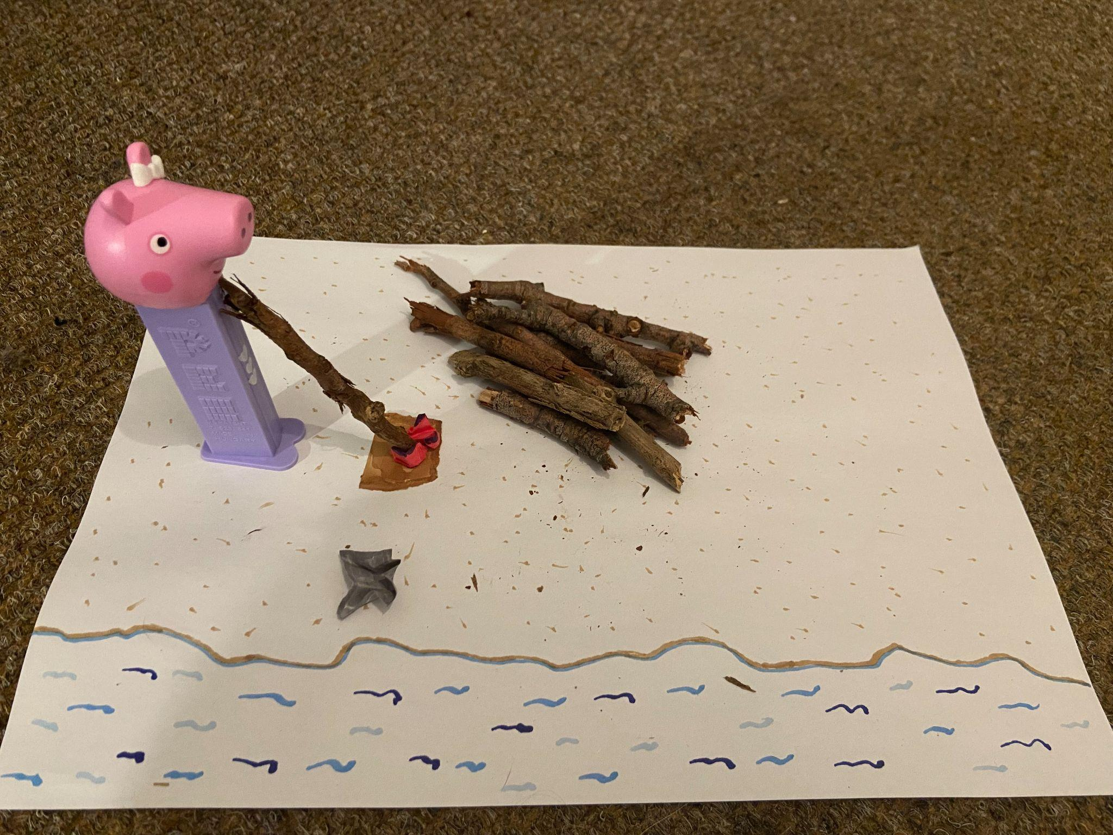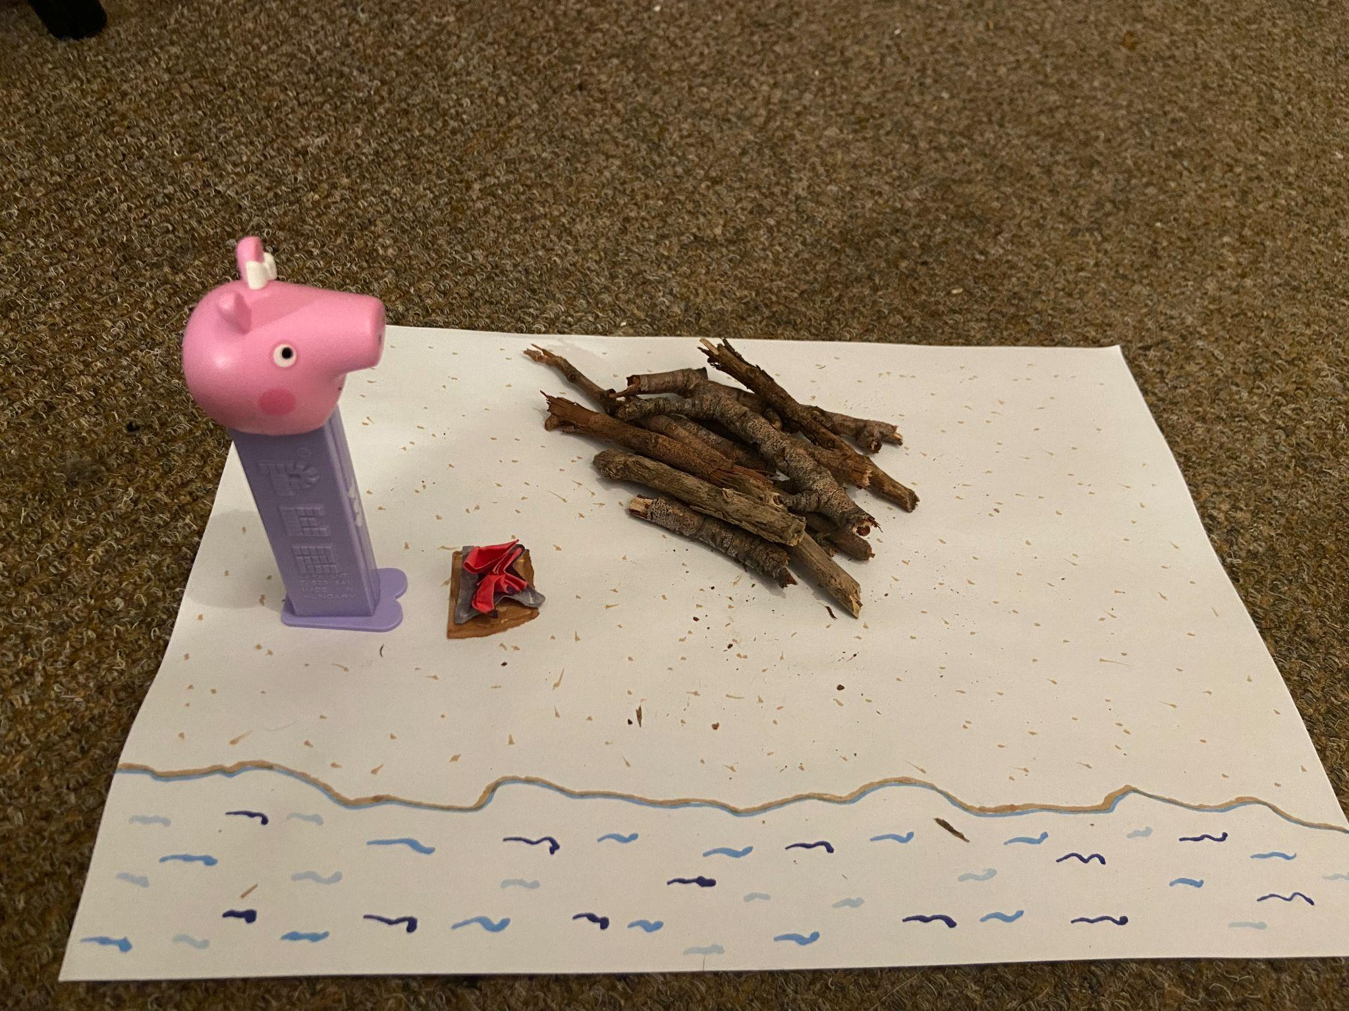

Jess started a fire by drilling wood Jess added foliage to enlarge the flame

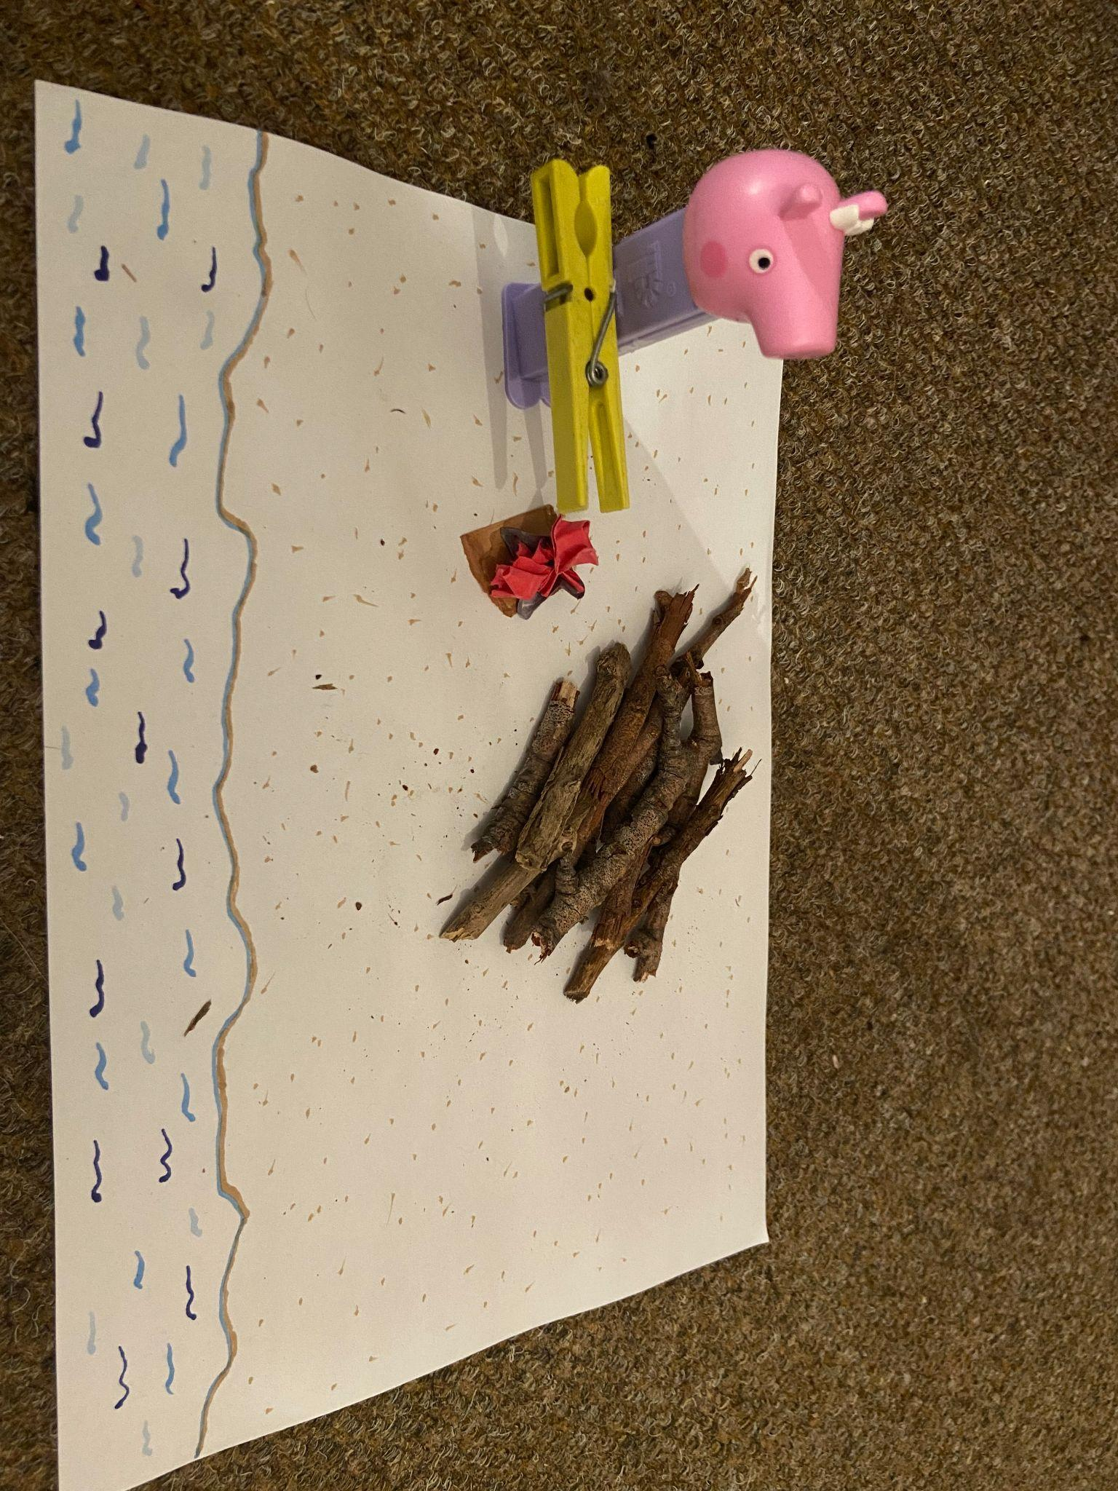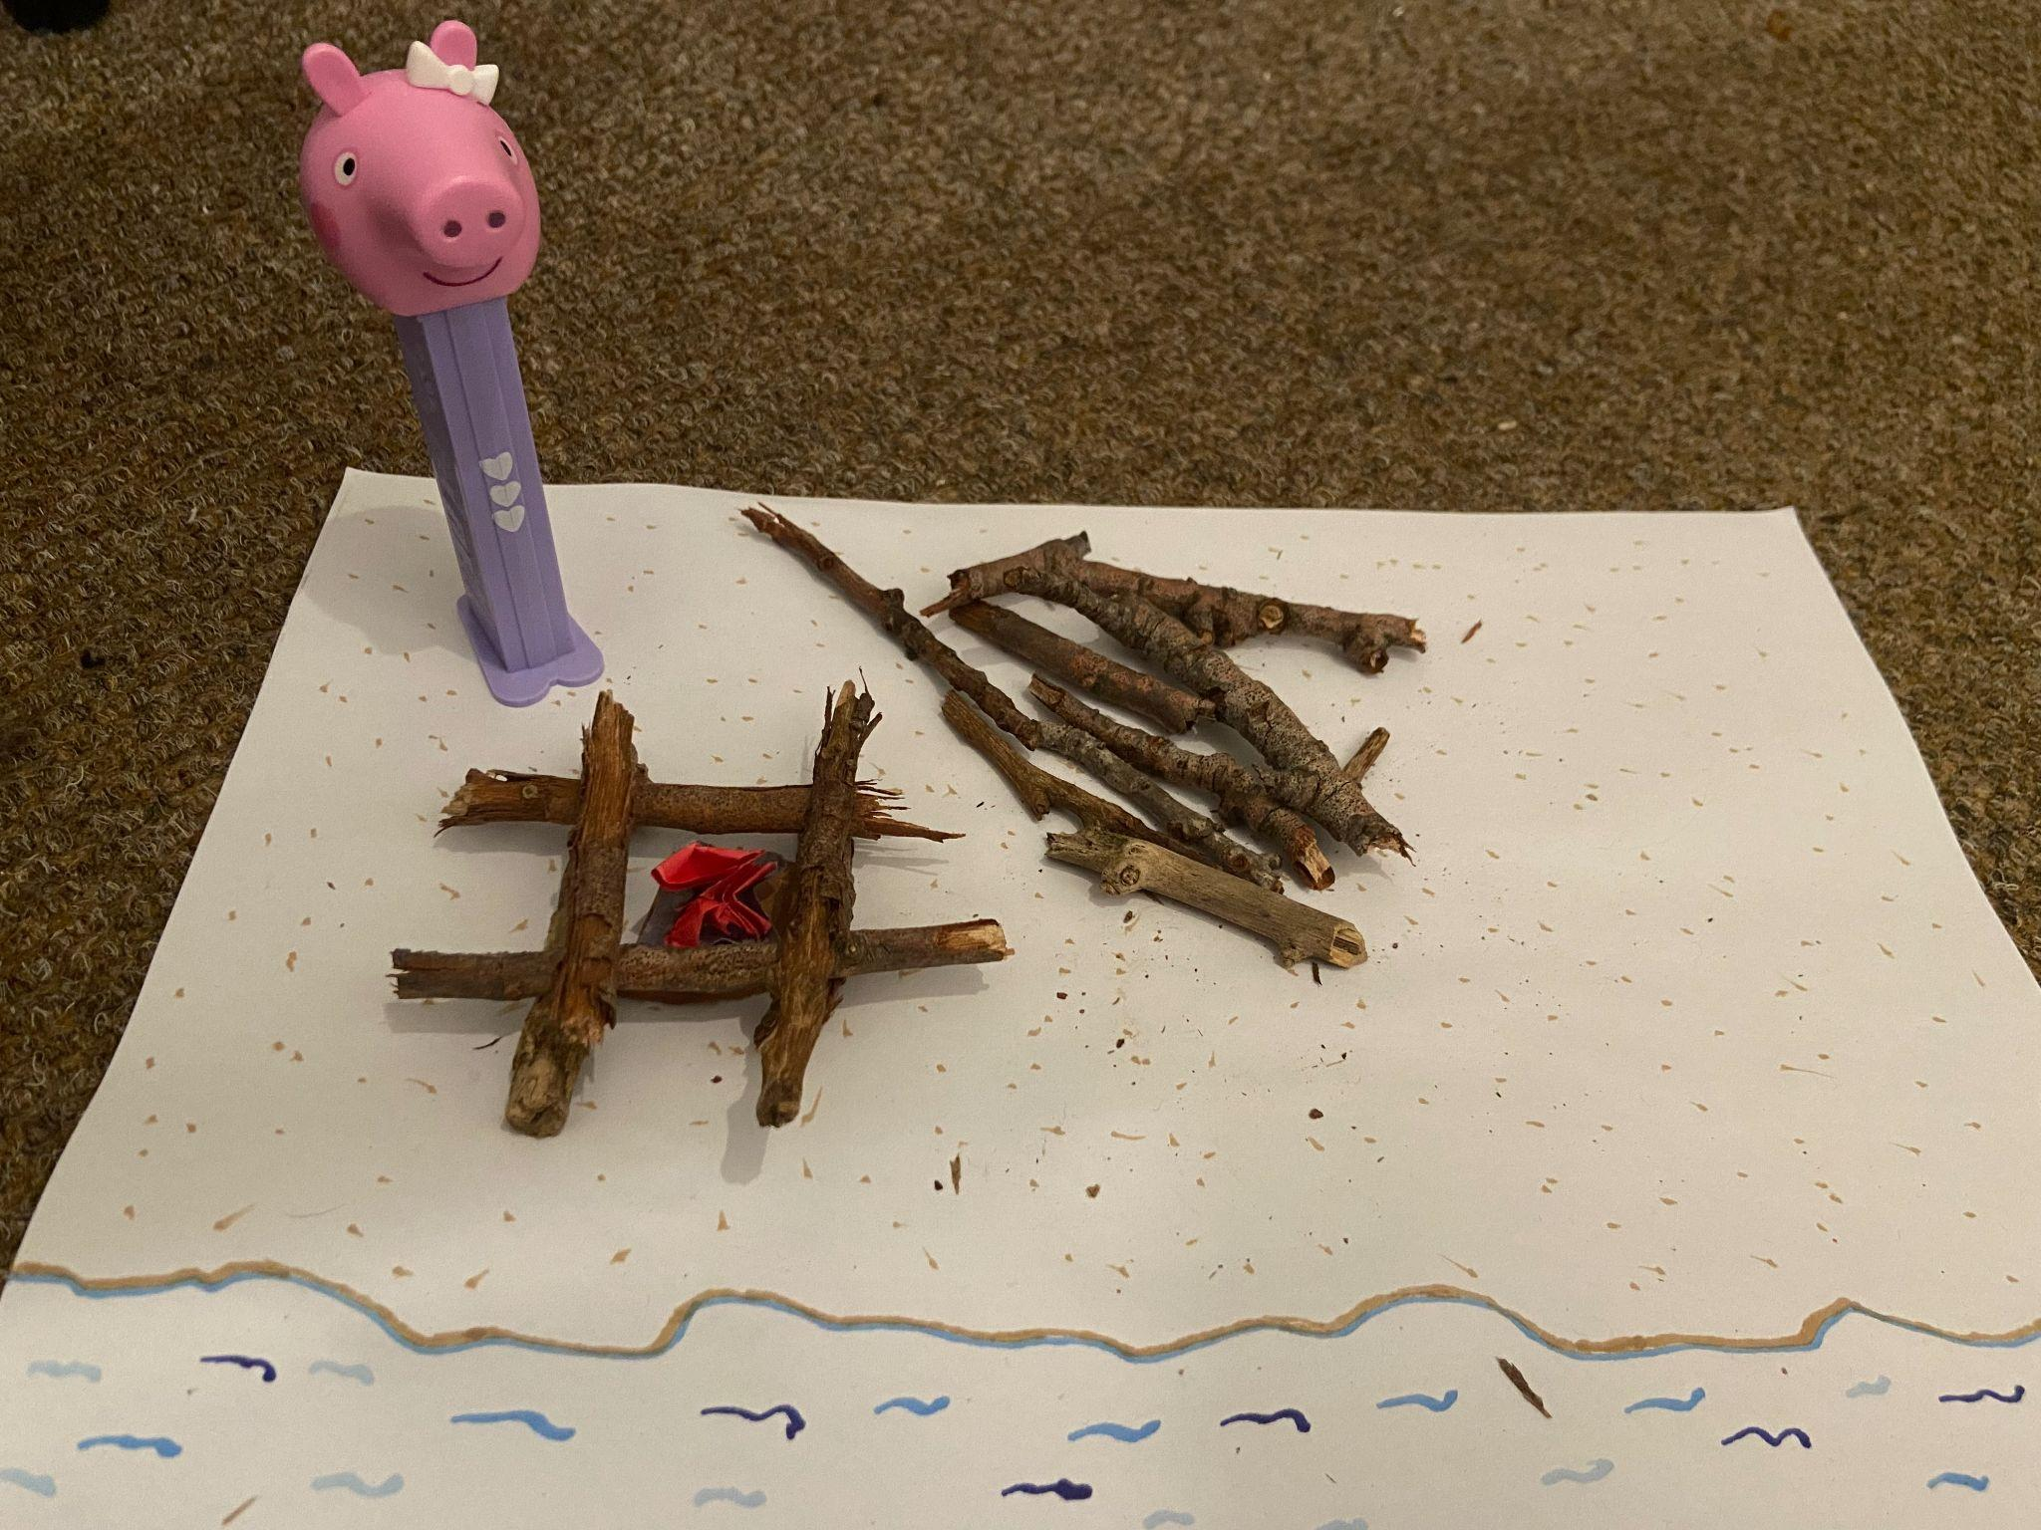

Jess fanning the fire Jess building the base of the bonfire

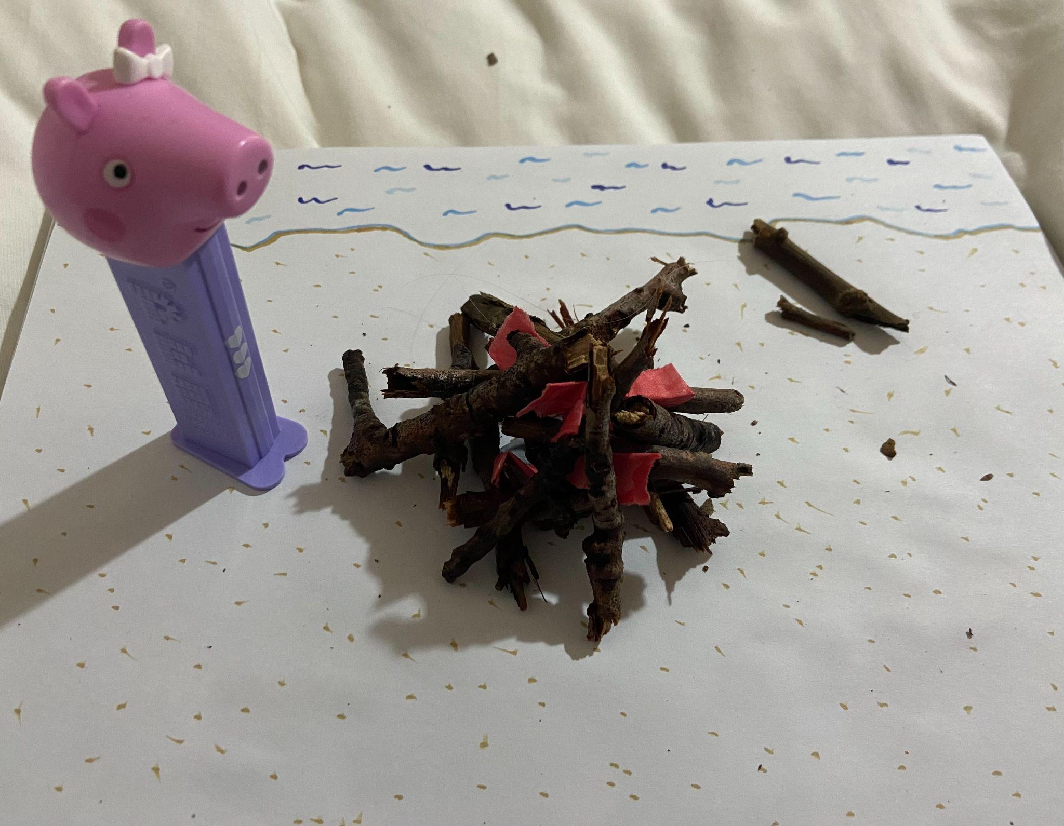

Jess completing the bonfire

Part 2: Relaxing and roasting marshmallows

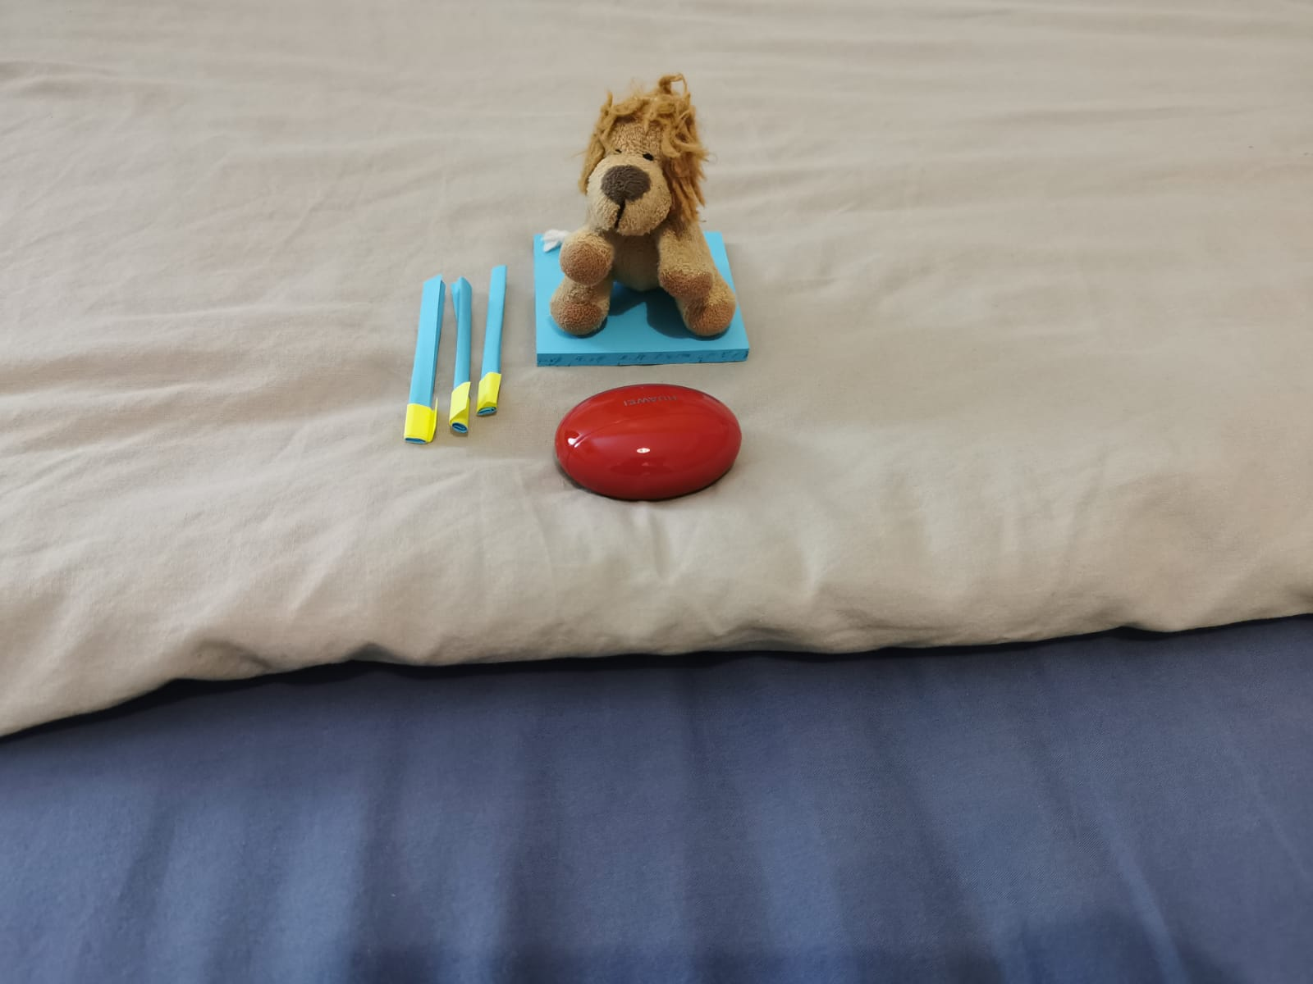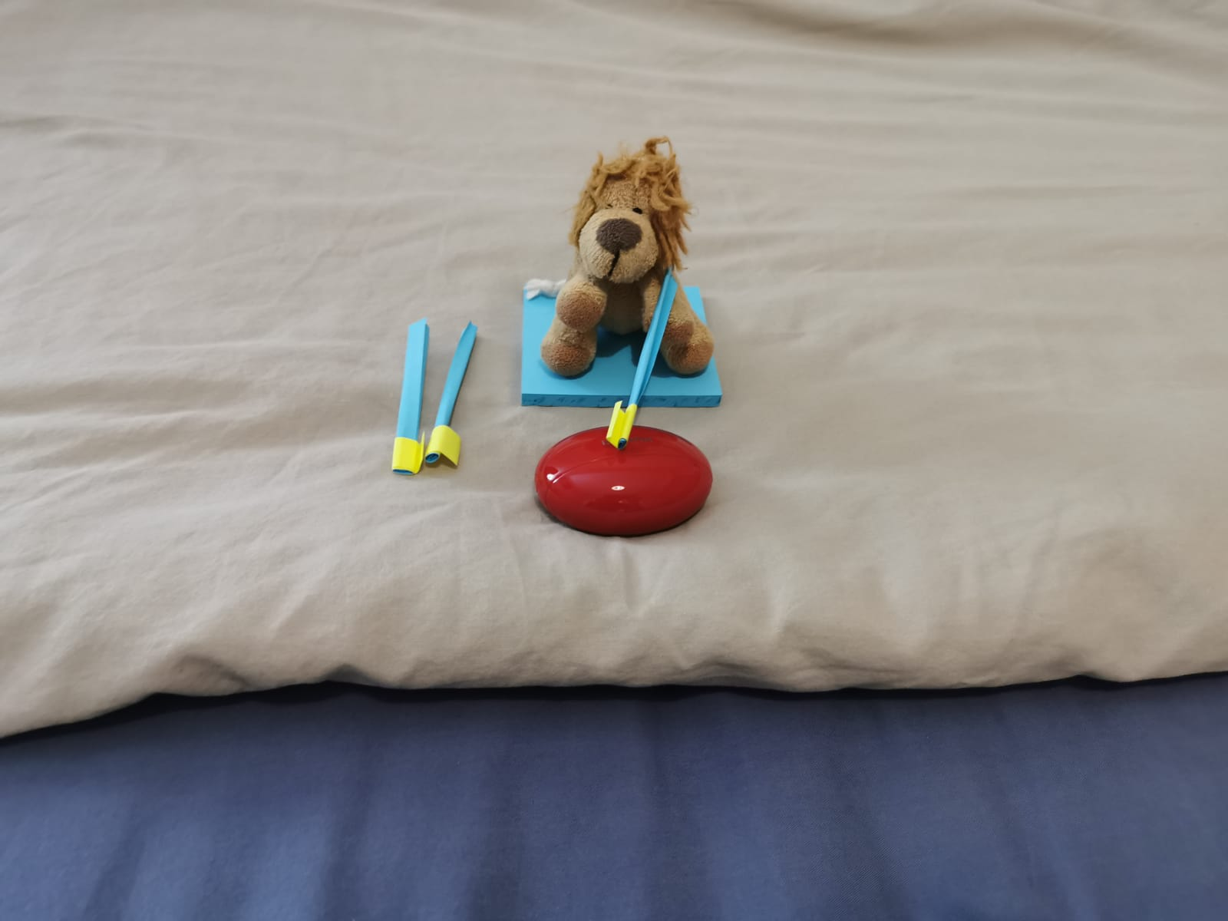

Jess relaxing next to the fire Jess roasting the marshmallow

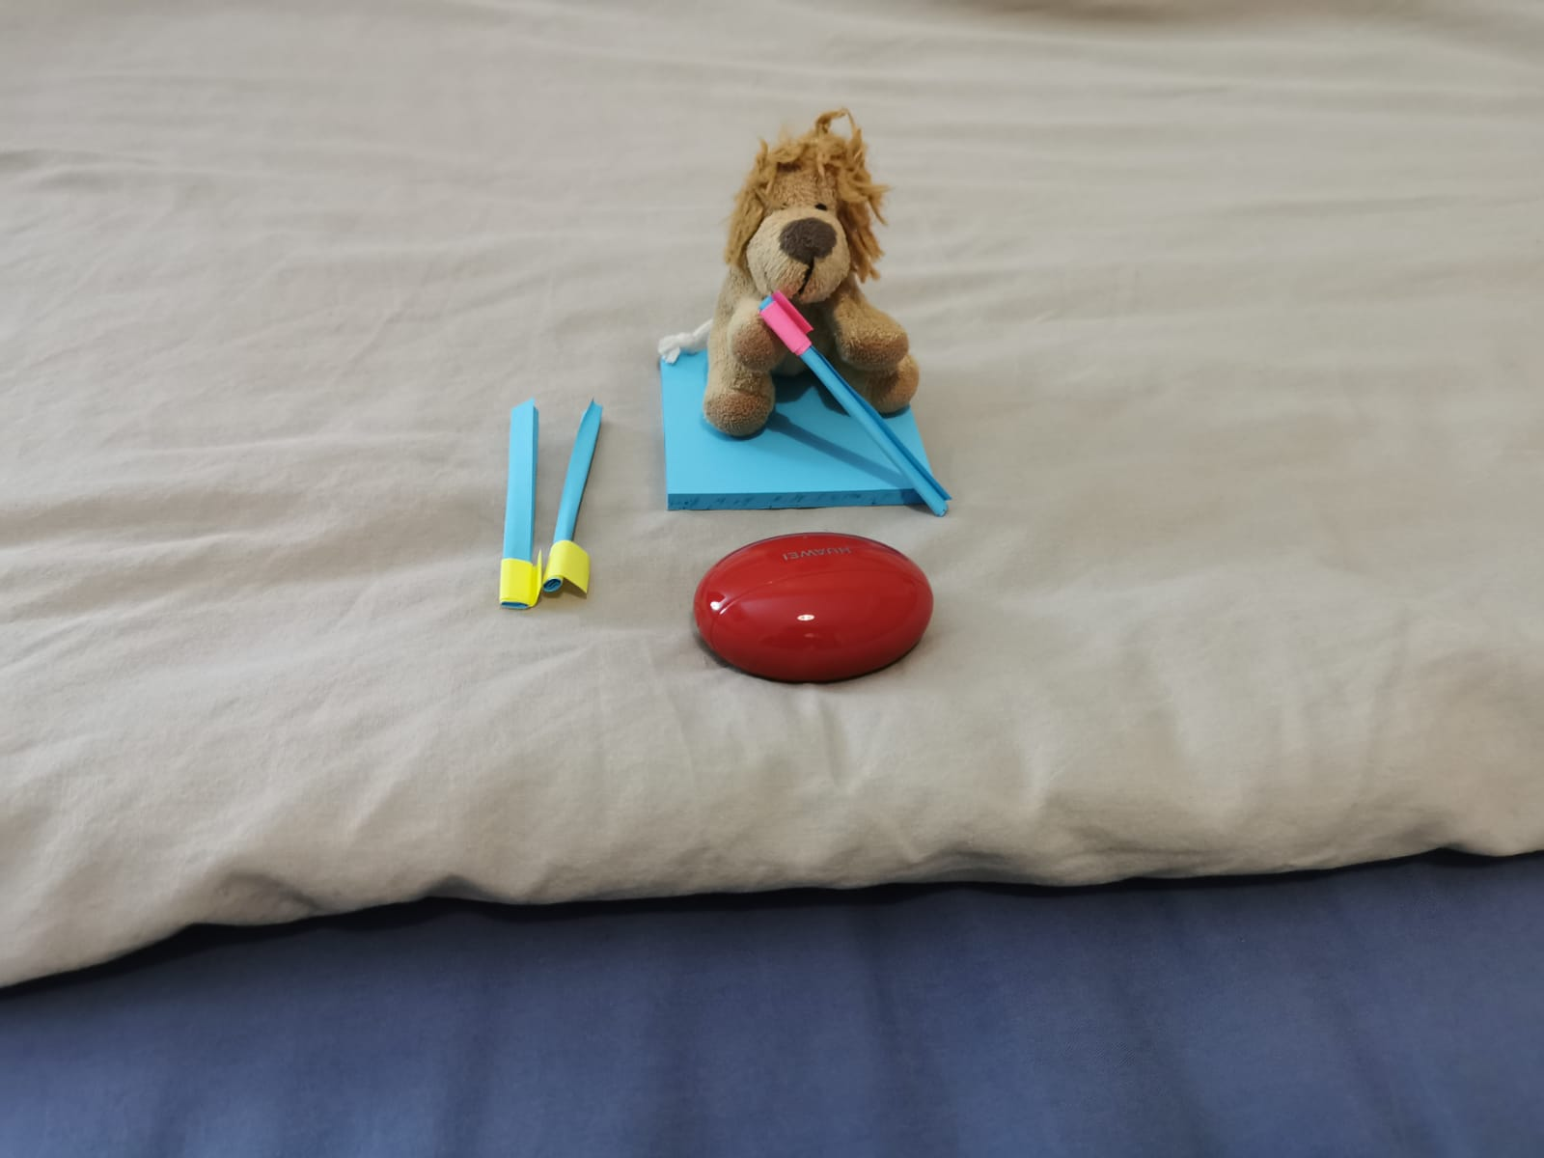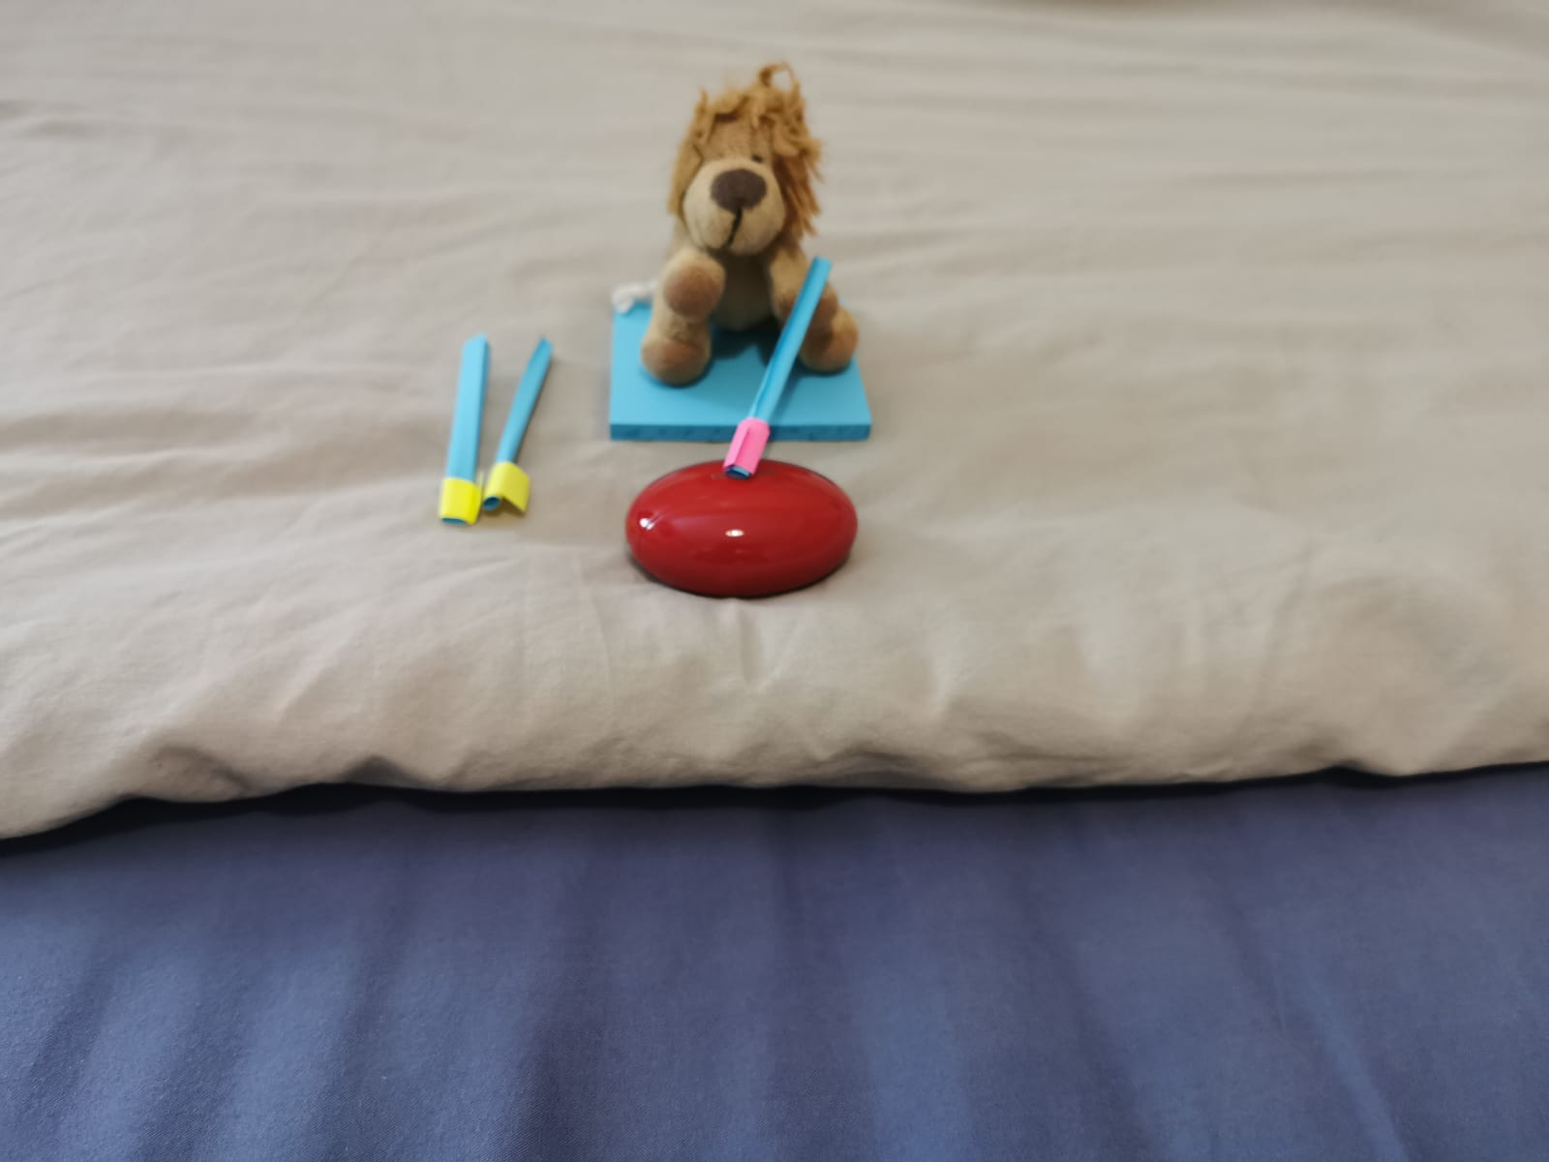

The marshmallow is roasted Jess is eating the roasted marshmallow

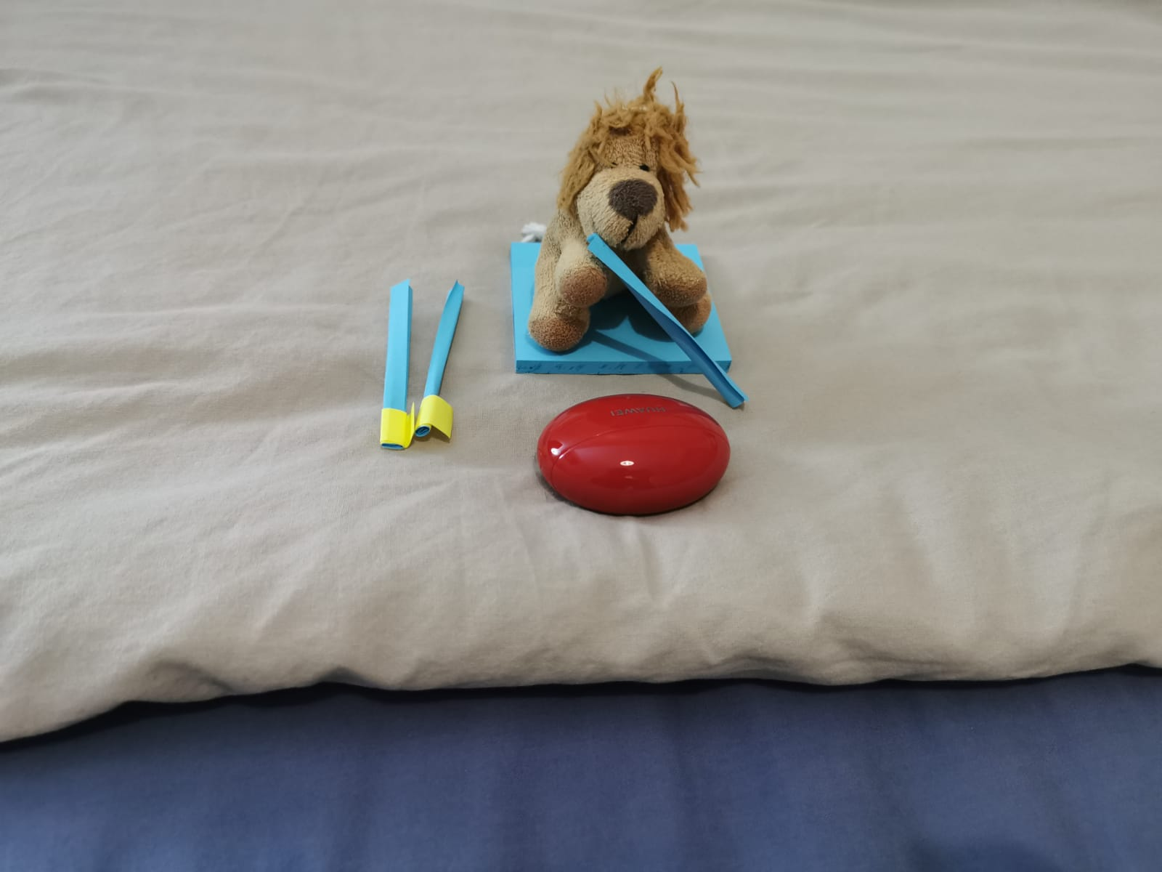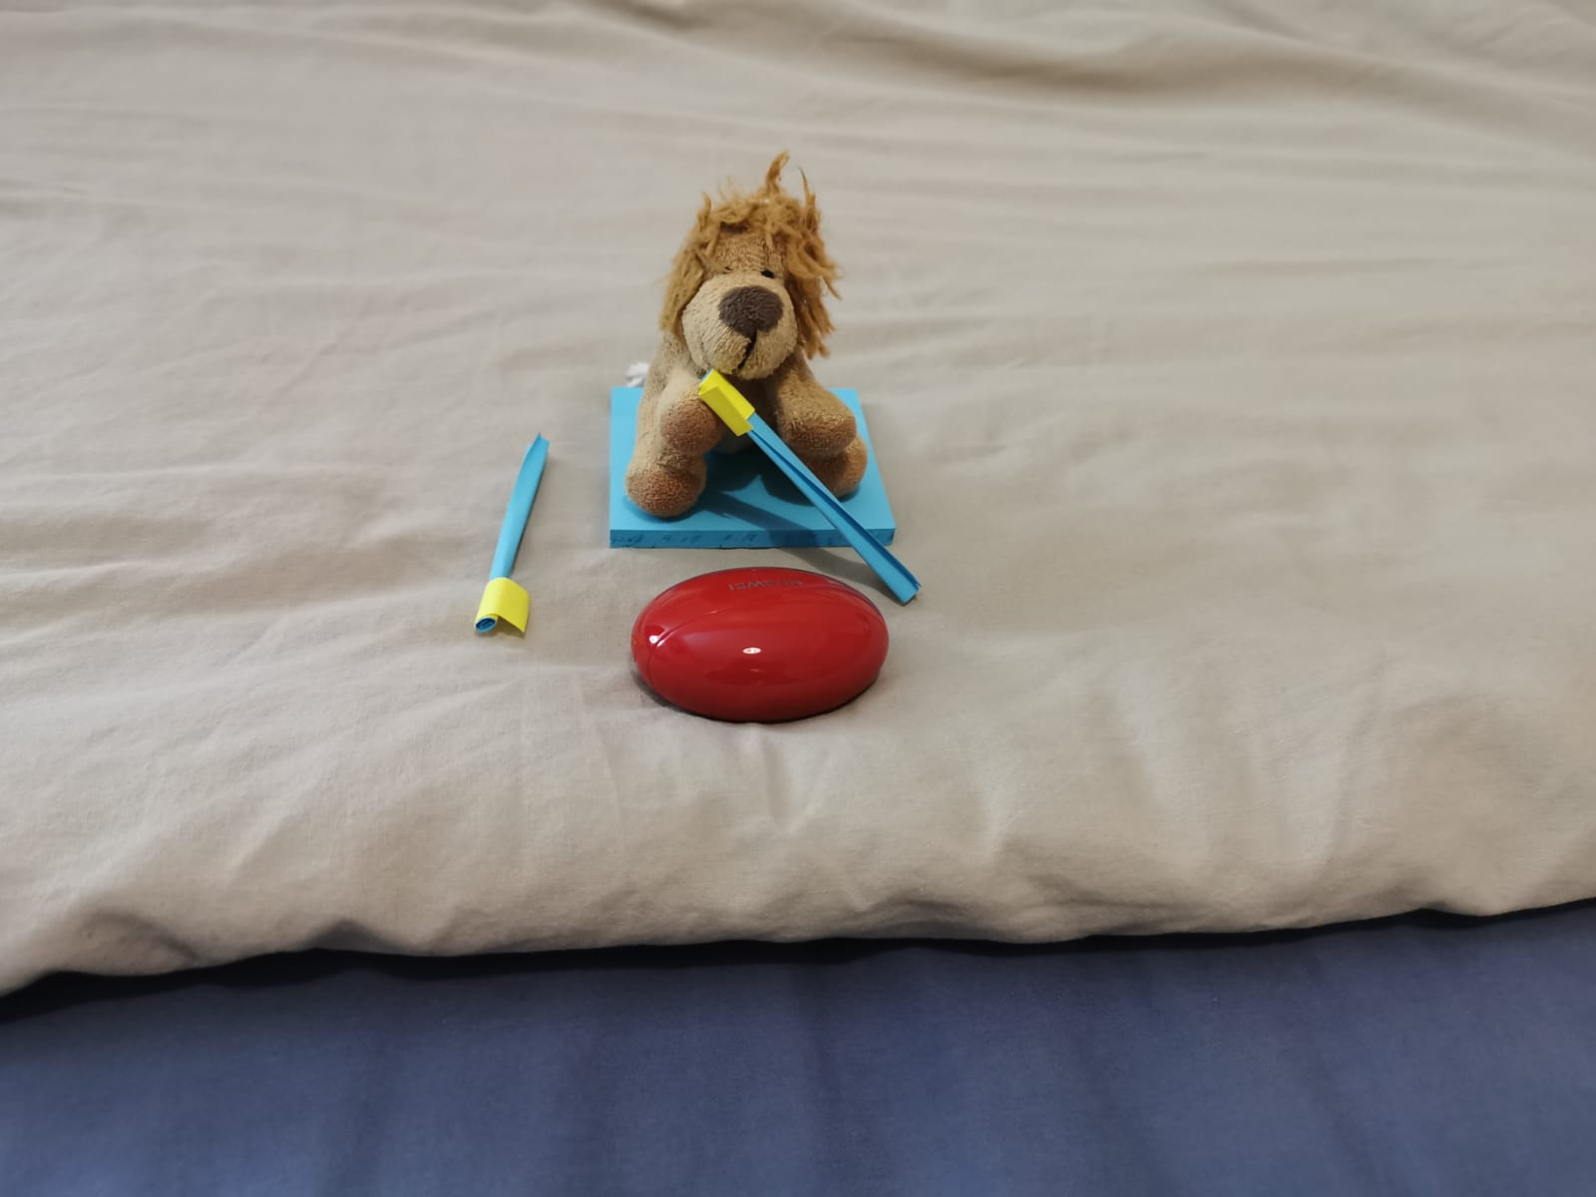

Or she can eat normal marshmallows Jess finished the marshmallow

Part 3: lit the torch and explore the area (Future scope):

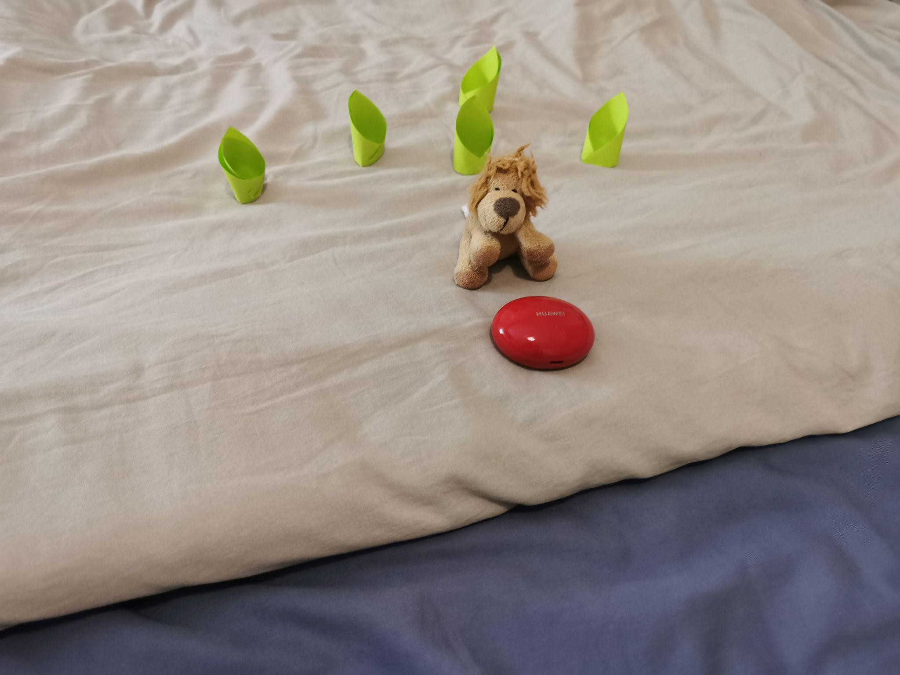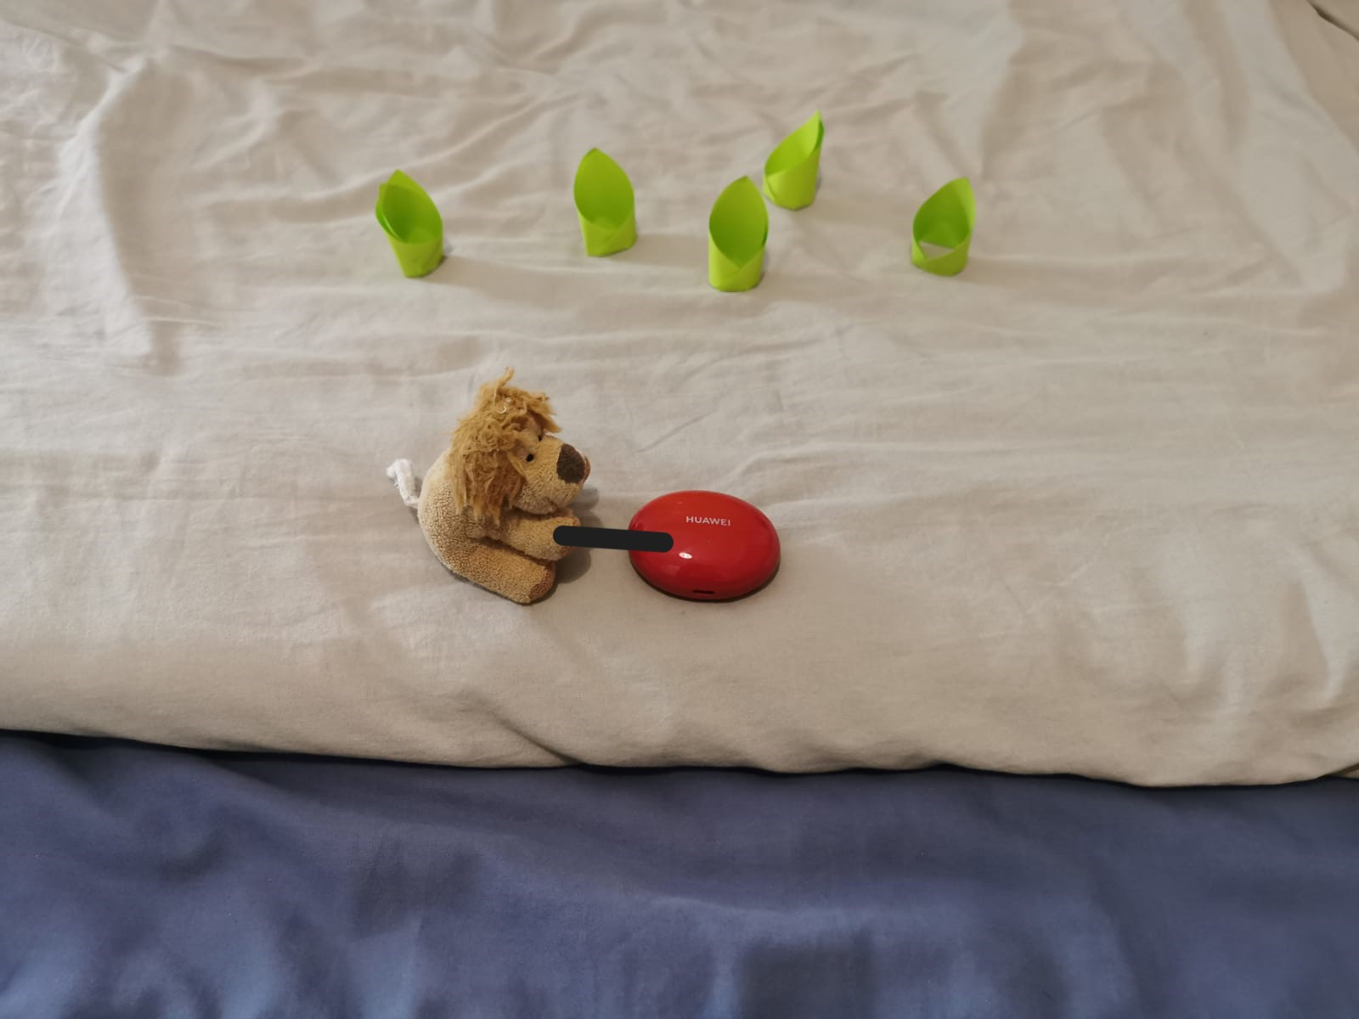

Jess is relaxing next to the fire Jess trying to light the wood

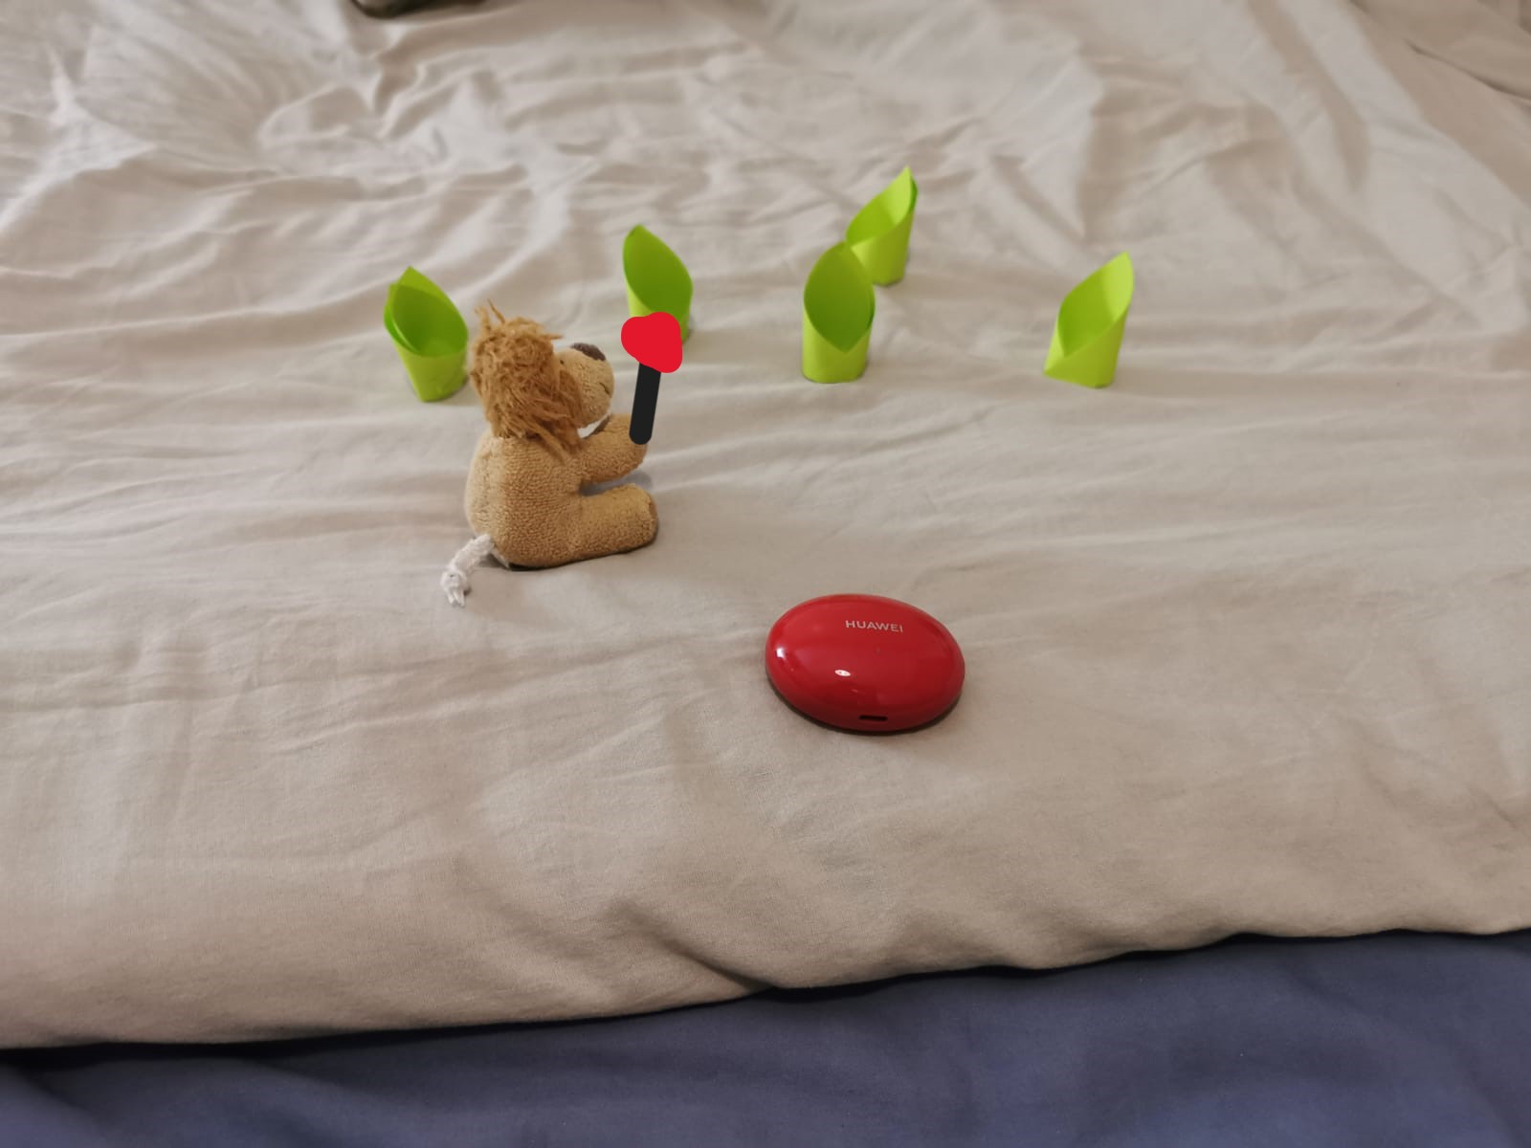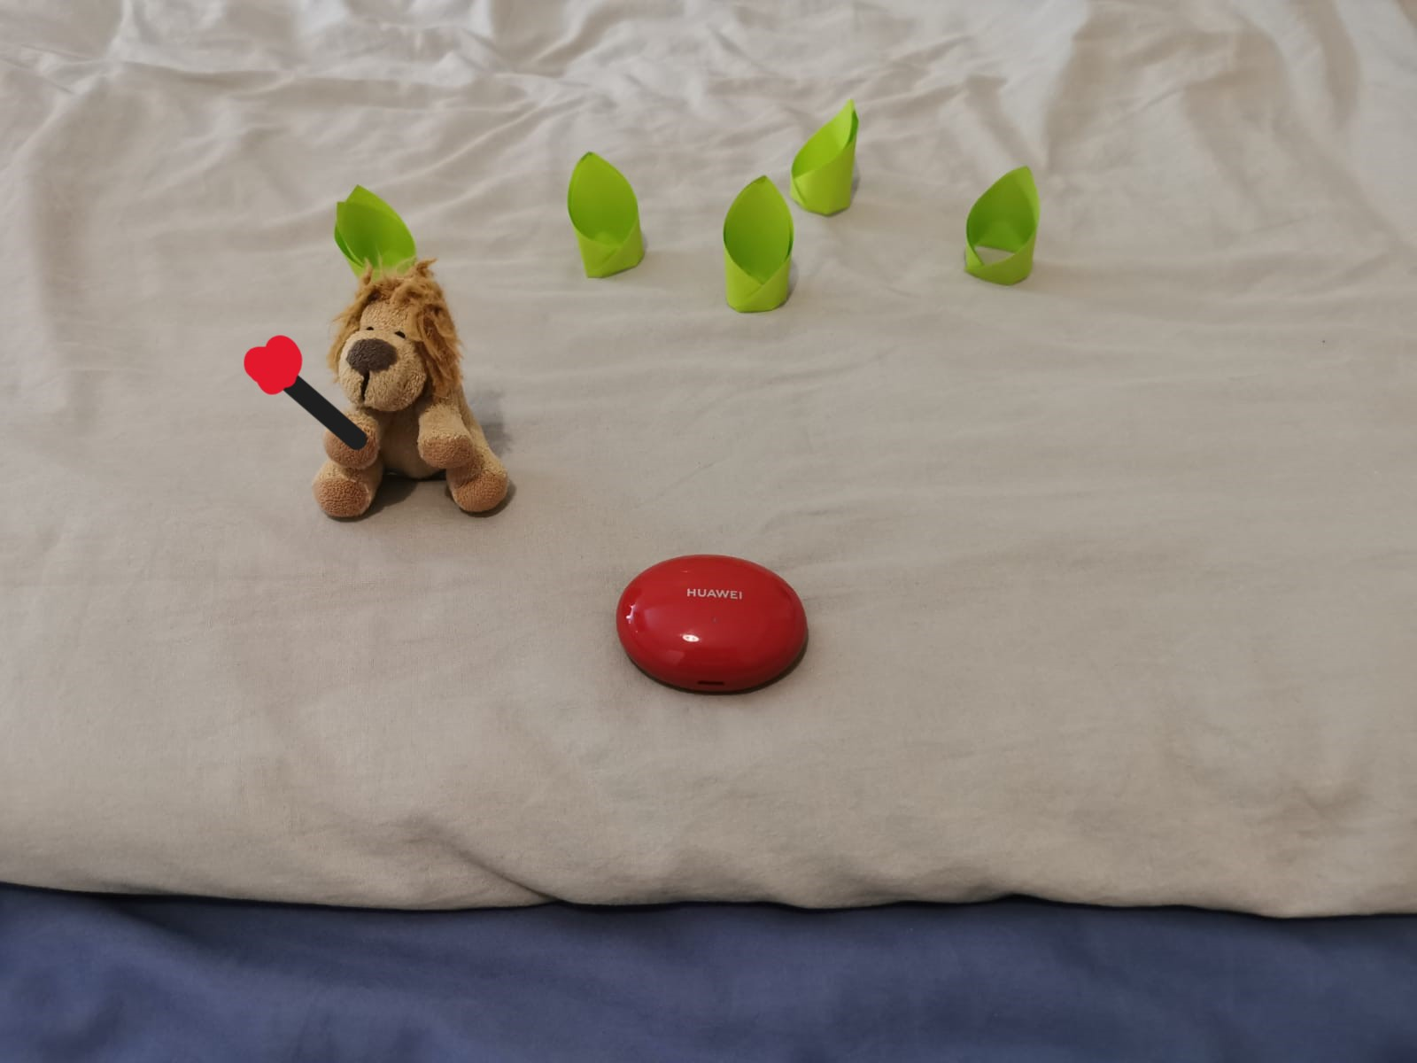

Jess successfully got a torch Jess is started to explore the woods

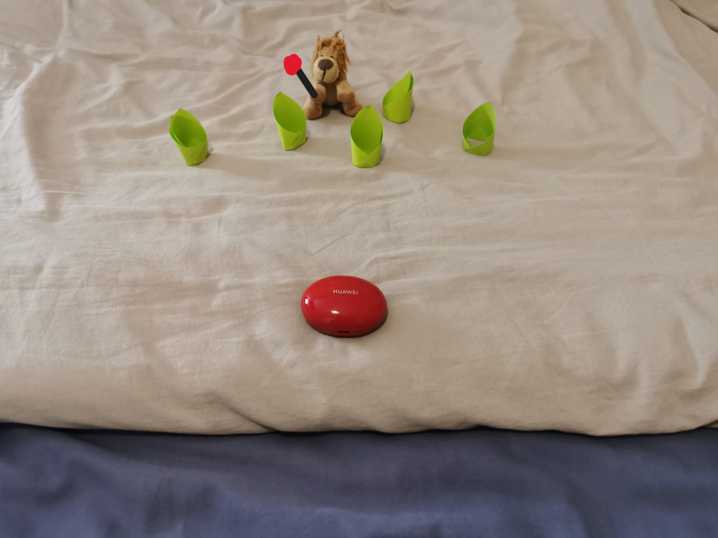

Jess just finished exploring

1. **VR Mechanics**
   1. Picking up objects

The user will be able to pick up certain objects that are lying around on the beach, namely wood to construct a bonfire and the drilling wood to create the fire. The user will also be able to pick up foliage and a fan to help the flame expand and a stick with a marshmallow to toast on the fire. The object that can be picked up will be highlighted and the user will be able to pick it up by holding in the left or right trigger on the controllers when close to the object. Depending on which trigger is pulled, the object will be gripped in the hand that pulled the trigger. The object will continue being held in the user’s hand as long as the trigger is being pulled, if the trigger is released, the object will also be released from the user’s grip. This mimics real life interaction, allowing the environment to feel more realistic to the user.

* 1. Sound, Visual and Haptic feedback

These types of feedback will be implemented to increase the immersive ability of the environment by making it more realistic. Haptic feedback will be implemented when the user picks up and holds objects, namely wood, the foliage and the fan, when the user drills the wood to create the fire and when the user toasts marshmallows. Audio will be added appropriately to include the soothing sounds of the ocean, the drilling of the wood, the fire crackling once the bonfire has been constructed as well as the sound of the fan used to make the fire bigger, and possibly wind. Visual feedback will be used to show progress the user is making. This includes moving objects in sync with the user’s actions, smoke emerging from the plank the user is drilling and eventually sparks and a flame being created. It also includes the fire growing as foliage is added to the flame and the bonfire being lit up as the flame grows due to the added wood. The changing colour of the marshmallow when it is being toasted also adds to the visual feedback that will be provided to the user to display that the marshmallow is being toasted.

* 1. Help

To keep the environment as realistic as possible, a piece of paper, that the user will find in their hands at the beginning of the game, will act as a guide on how to start a fire by drilling wood and how to effectively set up a bonfire. This will alert the user to what they need to do and how to do it. The paper guide will contain both text descriptions on how to perform the tasks as well as pictures to display what the objects needed and the overall bonfire structure should look like. It will provide steps that the user can follow to gather the required wood, foliage and leaf that will be used for fanning, how to drill wood to start a fire, and how to successfully structure the wood to create a stable bonfire. The user will be able to place the paper guide down and pick it up as necessary.

* 1. Drilling the wood

The user will be able to place a plank onto the ground and use a specific piece of wood to drill into the block in order to create fire. The user will move their hands holding the controllers back and forth, mimicking the movement of twisting the stick onto the plank to create fire. The speed at which they move the controllers and the length of time they move the controllers for will be used to determine if a fire will be created or if they need to twist the wood onto the plank faster or longer. If the user is twisting the wood at an optimum speed and has twisted it for a reasonable amount of time, smoke will start to appear from the plank, providing feedback to the user that they are getting closer to creating a fire. After more time, sparks will bounce off of the plank, followed by a small flame being created. If the user is twisting the wood too slowly on the plank, a text will be displayed, informing the player that they need to twist the stick faster.

* 1. Fanning the flame

The flame will be fanned using a big leaf that the user can find lying on the beach. A leaf was decided as the best tool to do this as it keeps with the theme of the beach bonfire and using survival skills, as it makes use of the objects available in the natural environment. The user will be able to pick up the leaf and move the controller in a fanning motion by twisting their wrist back and forth. The movement of the controller used to fan the fire will be tracked to determine if the fire should get bigger or not. This depends on if the user is fanning the fire at an appropriate distance to the flame and how fast the user is moving their hand.

* 1. Adding foliage

The foliage used to further increase the size of the fire and keep it burning, is a bird's nest. This keeps the theme of a beach environment surrounded by a forest consistent, instead of using modern tools such as blitz. The bird’s nest will be lying on the beach for the user to find and will be highlighted to indicate that it can be picked up. Once the flame is achieved through the drilling of the wood, the foliage is added to flame to keep it burning and also increase its size while the user then constructs a bonfire around it.

* 1. Constructing the bonfire

The paper guide will effectively instruct the user on how to successfully build a stable bonfire that will surround the flame the user created. The user will have gathered the wood necessary to do this before the fire was started to prevent the flame from going out before the bonfire can be constructed. The user will be able to place the wood for the bonfire where they want around the flame, however, the guide will instruct them how to do it efficiently to ensure the structure holds. The structure will consist of 6 bottom planks that are crisscrossed to provide a stable base, with the remaining wood being placed vertically above the base and leaning over them to create a tepee shape.

* 1. Chair

A camping chair will be present in the VRE, where the user can sit down and relax. An actual chair in the real world will be positioned behind the user as they try to take a seat to increase how realistic the environment feels. This action will trigger the time lapse from day to night where the user will feel as if they are falling asleep as the VR headset goes dark and will awake at night. This is when the user will find a marshmallow on a stick leaning against the camping chair where they can then proceed to toast the marshmallow.

* 1. Marshmallows

A time lapse will occur after the user has set up the fire and relaxes in the chair. It will seem as though the user fell asleep and will awake when it is dark. The user will then find a marshmallow already on a stick resting against the camping chair, which they can then hold over the fire to toast. There will be visual and sound feedback to alert the user that the marshmallow is being toasted, as there will be appropriate audio added and the marshmallow will change colour. There will be a threshold distance at which the user will effectively toast the marshmallow. Holding the marshmallow too far away from fire will not have any effect on it, whereas holding the marshmallow too close to the fire will burn it. We add either colliders or haptic feedback to prevent the user from burning the marshmallow to make the implementation simpler.

* 1. Environment and clutter

The environment will be primarily of the beach, with woods surrounding it. It will contain little clutter scattered around to prevent the user from picking up objects that are not to be used. The clutter will mainly consist of the tools needed to construct and light the bonfire, as well as a camping chair and a marshmallow. The simplicity of the environment will add to the serenity of the beach environment, allowing the user to relax.

1. **Object Design**
2. The wood for the bonfire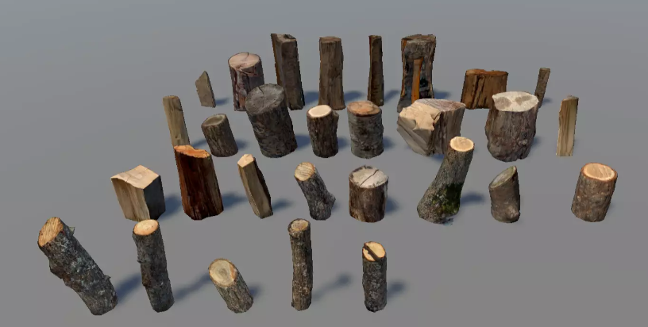

A free wood asset pack from unity was decided on as it provides a variety of realistic wood, namely hardwood, to be used to create the bonfire. Since the wood is only going to be used to be picked up and structured into a bonfire, a free asset with simple implementation was chosen.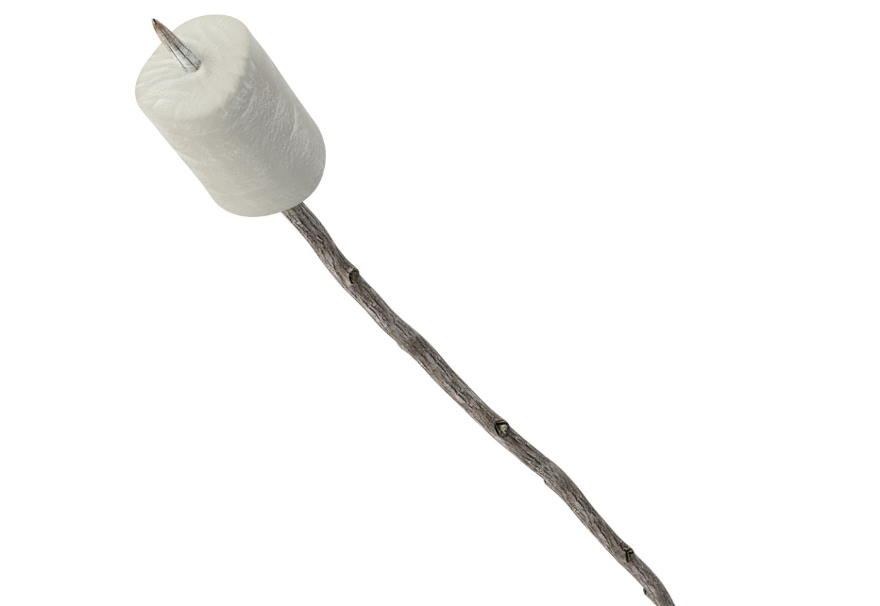

1. The foliage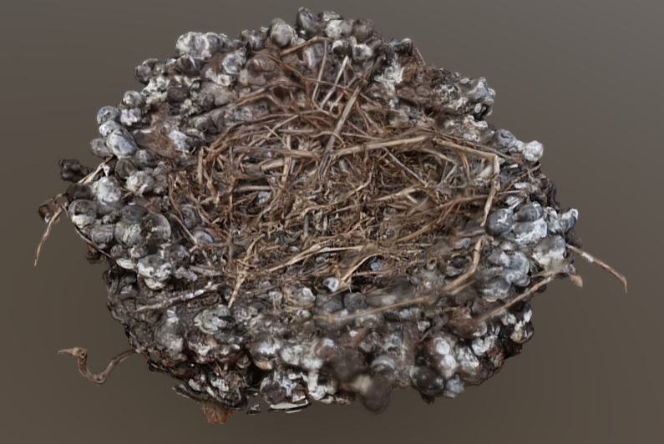

A free 3D, bird’s nest was found that can be edited in Blender to use as foliage. A bird’s nest is a good option for foliage as it is easy to burn but does not burn too quickly. It will be edited to change colour and shape for when it is burning.

1. Fire and smoke

Particle systems will be created to implement realistic fire and smoke. As this is an important component of the VRE to make it as realistic as possible, we will design it ourselves if one cannot be found.

1. The drilling wood

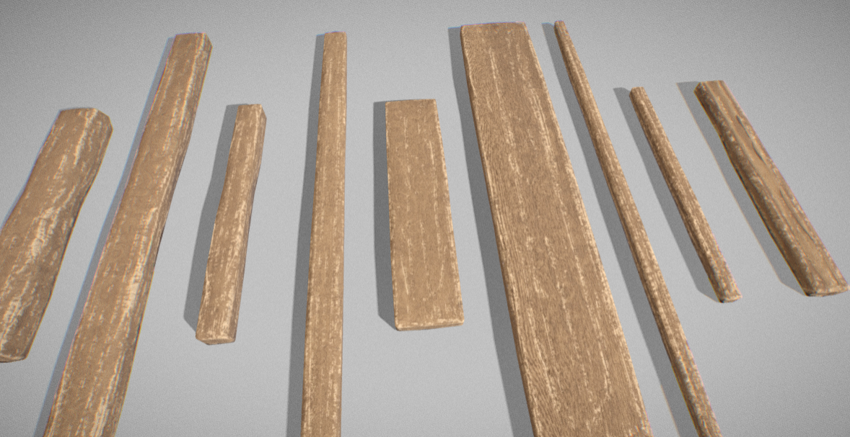

A free 3D asset was chosen for the drilling wood as it replicates realistic softwood, the best type of wood to be used to create a fire through the process of drilling wood. This pack also comes with a variety of shapes and sizes, where one can be designated to do the drilling and the other to be used as a plank that will be drilled.

1. Camping chair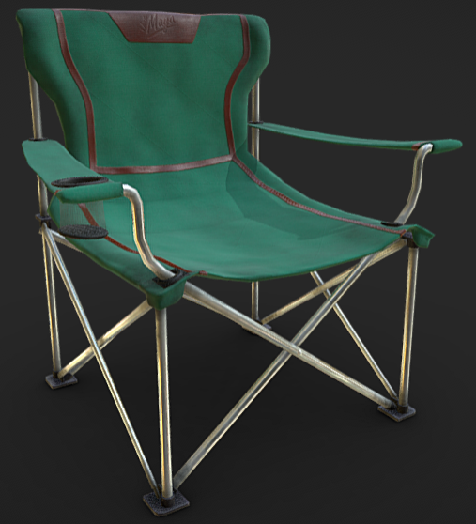

A free 3D camping chair was found that is also very realistic. The camping chair is only for the user to sit on, therefore, a simple free asset was chosen.

1. Fan

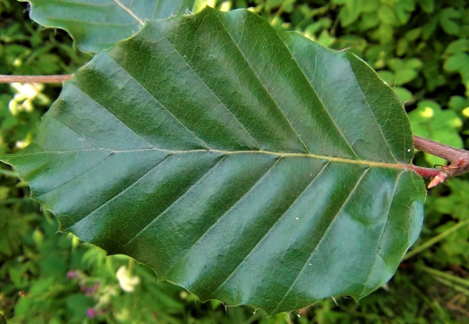

A leaf to be used to fan the fire will either be designed or found and edited as it needs to be able to move according to the user’s movements when fanning the fire. This is an important requirement as it will take away from the immersive ability of the VRE if it does not move naturally.

1. **Audio Assets**

Audio is one of the stimuli that is often forgotten during development, however, audio has been proven to be effective for inducing presence in users. Therefore it is important to put a high level of focus on this aspect.

The audio asset will be obtained from either the built-in audio of the asset obtained from the asset store, or we will find audio from the internet. If necessary, we will obtain the audio from recordings.

The following part of the VE will have a high focus on audio quality.

* Sound of the ocean
* The sound of the fire
* Sound of drilling wood to make fire
* Sound of wind breath.
* Sound of the player's movement

As mentioned earlier, we will highly focus on these parts of the VE for audio. However, this does not mean we are only focusing on this area, it is just the part of the environment we believe that users will easily pick up if audio is ignored or not right.

1. **Testing**

We will be using two different testing methods for this project, pull request quality assurance and heuristic testing.

Firstly, we will be code reviewing each other’s code before they are merged into the main branch. We will do this by using the pull request feature in git, so before something gets merged into the main branch, a developer will first need to review the code and approve it before any merge happens. This will ensure high code quality, maintainability and consistency.

Secondly, we will be using heuristic evaluation for testing our environment 7 days before submission. The benefit of heuristic evaluation is that it is cheap, fast and provides high-quality feedback. For this project, we will use Nielson’s Original Heuristics where we will be evaluated based on the list of 10 usability heuristics. We will invite 3 classmates in VR to test our VR. The feedback will be in a verbal format and we will note that in our final iteration of agile methodology to develop and fix any features that we have implemented.

1. **Future Scope**

**Exploration**

Our project is mainly focused on the camp. However, if time allows, we want users to be able to explore areas outside the camp. To achieve this, users must first light a torch using a wood stick and campfire. When the torch is lit, users can either explore the beach or the woods behind the users. The night will be a bit brighter as we do not want to make a scene where users will be surrounded by darkness. So the light from the moon will be bright enough so users won’t experience fear due to the darkness.

**Chopping wood for fire**

One other feature in our future scope is that the players can cut down the wood themself to get the sticks and planks. To achieve this, the user will be introduced to another tool, axes. The tree will have a hidden health bar, and every time the player strikes it, it will lose some of its health, until it reaches 0. Once the health of the tree reaches 0, it will fall and become sticks and planks. For the simplicity of this project, the tree will automatically become sticks once it reaches 0 health, similar to the cutting trees in the game “Terraria” or “The Forest”.

**Scaring off predators**

Another scope that we can implement is scaring off predators. So, this will occur during the night when wolves are howling, the user can light a torch to scare off the wolves when they come then wave the torch at them in defence. After some time, the wolves will leave the scene.

=